**Sakila MYSQL :**

For the homework, queries were written using Sakila database. Sakila is a sample database that was provided by MySQL for learning query language. It is a movie rental database that has data related to movies like movies and their description, their categories, actors, when and where they were rented, how much revenue they generated etc. Below show the details on what is included in the database.

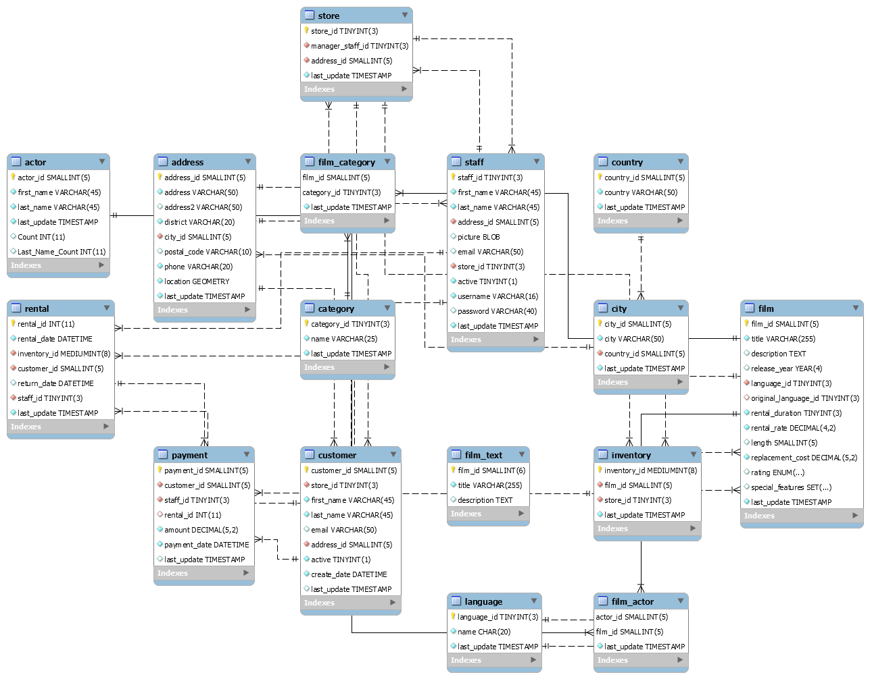

**Methodology (types of SQL queries used):**

The following types of queries were used to generate the output:

* Subqueries
* Joins
* Views
* Rollbacks
* Select
* Create
* Update

**Broad summary of results/ SQL output:**

1. The top 5 genres that generated the most revenue are as follows:

* Sports
* Sci-Fi
* Animation
* Drama
* Comedy

1. The Canadian store bought in more revenue at 37,001 than the Australian store which generated 30,414.

**Conclusions/Final Thoughts**

I personally would never have thought that Sports would be the category that generated the most revenue considering how much people already spend on cables to watch sports.

**Limitations/Future data exploration ideas of Sakila (edited)**

The data collected were only for Canada and Australia. It would be more interesting if they had added US data for comparison.

It would have been interesting to see how many days the movies were rented for but actually how many days the renters kept the movie. We could thus check how much fines were generated.